DISK :-
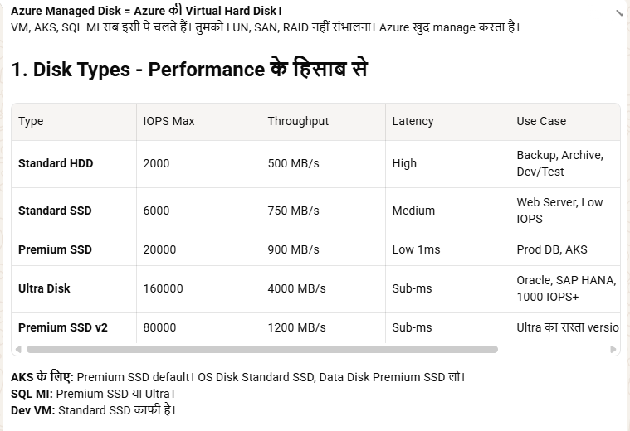
Azure Managed Disks = VM ke liye block storage (PaaS)
👉 Azure handle karta hai storage account, HA, scaling
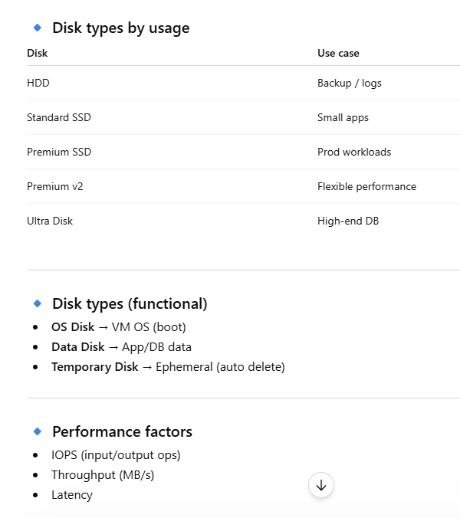
🔹 HA / DR
- ZRS disks (zone redundancy)
- Snapshots / backups
- Disk replication (ASR)

🔥 Real example
- Dev VM → Standard SSD
- Prod App → Premium SSD
- High DB → Ultra Disk

🔥 Interview one-liner
👉 “Azure Managed Disks provide different performance tiers like Standard, Premium, and Ultra, and the selection depends on workload requirements such as IOPS, latency, and cost.”
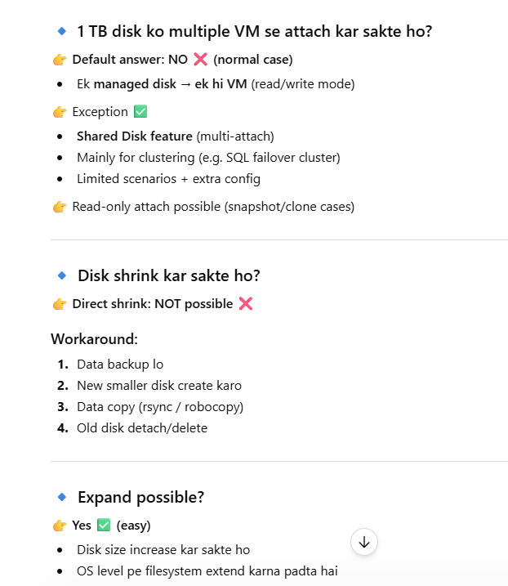

🔹 Azure me Disk create kaise karte hain (steps)
✅ Method 1: Azure Portal (easy)
- Azure Portal → Disks
- Click + Create
- Basics fill karo:
  - Subscription / Resource Group
  - Disk name
  - Region
- Source choose karo:
  - Blank (empty disk)
  - Snapshot / existing disk / image
- Size & type select karo:
  - Standard / Premium / Ultra
- Review + Create
👉 Disk ready ho jayegi

🔹 VM me attach kaise kare
- VM → Disks → + Add data disk
- Existing disk select karo
- Save
👉 OS me mount karna padega (Linux: mount, Windows: initialize)

VURNEBALITEIS:-

